**Henry Rutledge**

Henry Rutledge was born about 1789. He gave his birthplace as Tennessee. No evidence has yet been found linking him to the famous Rutledges of South Carolina or any other prominent Rutledge family. Henry's wife Sarah was born about 1795 in Kentucky. They most likely married about 1815. Henry is found on a voter list in Jackson County, Tennessee in 1812. He served as a Private in Captain Sutton's Company and Colonel Woodfolk's Battalion of the Tennessee Militia in 1814-15, which guarded Fort Jackson, Alabama during the War of 1812.

Tax records indicate that Henry and Sarah moved to White County, Tennessee about 1820, but never owned any land there. There may be a connection to a John and William Rutledge who were also found in the records of Jackson and White Counties at the time, but more research is needed to determine whether a family relationship exists. The family moved to Carroll County, Arkansas during the 1850s. Henry received about 86 acres of bounty land in Madison County, Arkansas for his service in the War of 1812 (NW1/4 of S6 T16N R24W). In 1860 he purchased 40 acres in Madison County (NE1/4 NE1/4 S8 T17N R24W), but is listed as "of Carroll County" and appeared in Carroll County on the census.

His youngest daughter Lucinda died in 1861. Jacob J. Rutledge, the youngest son, contracted measles in the service and died in 1862, leaving a widow and child. Charles served in the cavalry on the Confederate side. William is listed as having served as a private in a Union unit near the close of the war. Although the exact dates are unknown, it is believed that Henry and Sarah died during the late 1860's, as Henry disappears from Carroll County tax records about 1868, and neither appears in the 1870 census with their children. Several members of the Rutledge family are buried in Lower Campground Cemetery in Madison County, Arkansas.

Henry and Sarah's known children were:

Isabelle (1818-1892) never married  
Charles J. "Charley" (1820-1909) married Minerva Moore (3 sons and 3 daughters, see below)  
William (1823-1890) never married  
Elizabeth (1825-1890) married Stephen Howard, a widower (no children)  
Susan Jane (1825-after 1910) married 1. Joshua Fox, 2. Felix Hawkins (unclear if she is the mother of his youngest son)  
Mary A. (1830-after 1920) never married  
James H. (1832-before 1900) married Sarah E. Blythe (2 daughters, Jane and Mary)  
Lucinda (1836-1861) married William J. Hudson (3 daughters, Margaret, Sarah, and Lucinda)  
Jacob J. (1836-1862) married Alsia Jane Litterell (1 son James Frank Rutledge, 1859-1932)

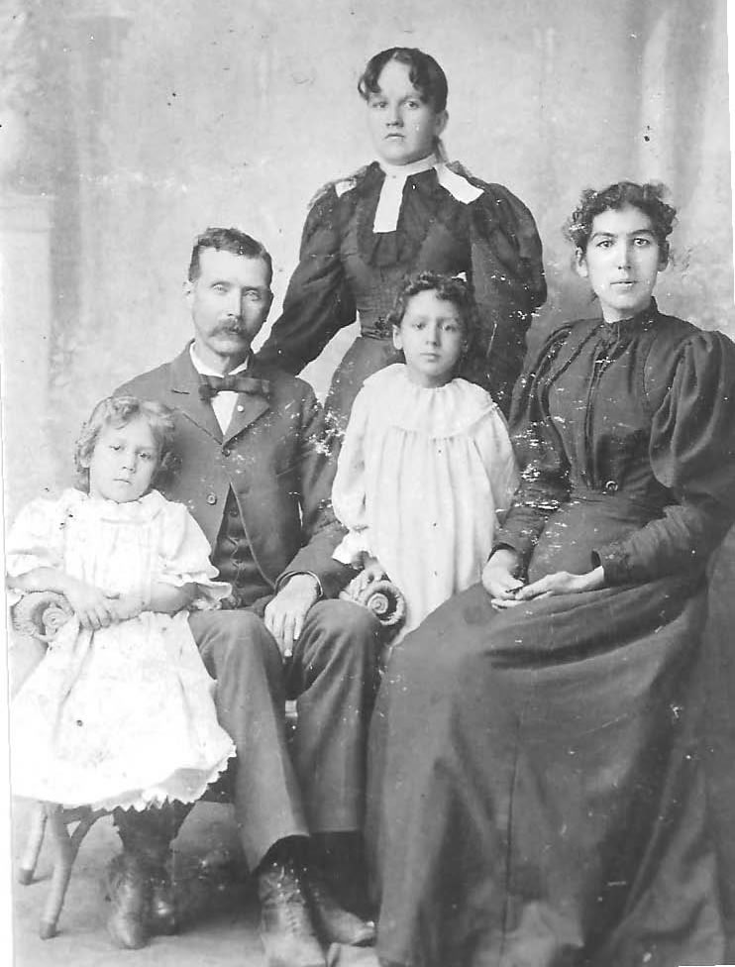Charley married Minerva [Moore](http://scottandrhonda.com/family/Moore.htm), daughter of Matthew G. Moore and Mary Norvell, on November 30, 1843 in White County, Tennessee. Between 1850 and 1853 Charley took Minerva and their children and moved to Madison County, Arkansas where Minerva's sisters had settled earlier.

Their children were:

William Narval (1847-1900) married 1. Sarah Howard, 2. Amanda Taylor  
James (1849-1939) married 1. Anna Merchant, 2. Mirilda  
Mary J. (1853-????) married James W. Howard  
Sarah Lewis (1854-1935) married Thomas Jefferson Green  
Rebecca Ann (1858-1878) married Thomas Howard  
Jacob Owen (1860-1922) married 1. Mary Elizabeth Meade, 2. Julia Ann Elliot